Career outcome expectations among pre-service teachers: proactive personality, job search clarity and career-related AI use
Mohan Zhang
Jing Hengyi School of Education, Hangzhou Normal University, Hangzhou, Zhejiang, China
Jingyi Lou
Institute of Curriculum and Instruction, East China Normal University, Shanghai, China

Abstract
Purpose – This paper examines how proactive personality is associated with career outcome expectations among pre-service teachers, whether job search clarity accounts for part of this association and whether the remaining direct association differs by self-reported career-related AI-use status.
Design/methodology/approach – In December 2023, online questionnaire data from 650 pre-service teachers at a Chinese teacher education university were analysed. Preliminary reliability, descriptive and correlation analyses were conducted in SPSS. Item-level latent variable analyses were then conducted in Mplus, including confirmatory factor analysis, latent mediation modelling, measurement invariance testing and multi-group latent structural equation modelling.
Findings – Proactive personality was positively associated with job search clarity and career outcome expectations. Job search clarity showed a significant indirect association between proactive personality and career outcome expectations, while the direct association remained significant. The direct coefficient was significantly weaker among participants who reported career-related AI use than among those who did not.
Practical implications – Teacher education programmes should combine career goal clarification with guided and critically evaluated AI-supported career activities, rather than treating access to AI tools alone as sufficient career support.
Originality/value – The paper extends the social cognitive model of career self-management to the teacher-education-to-employment transition by integrating personal agency, job-search goal clarity and self-reported career-related AI use within a single latent-variable framework.
Keywords: pre-service teachers; career outcome expectations; proactive personality; job search clarity; career-related AI use; career self-management model
Article classification: Research paper

Introduction
The transition from teacher education to employment is consequential for both graduates and education systems. Global policy debates have increasingly focused on teacher shortages, retention and the attractiveness of teaching as a career. The latest global report on teachers projects a shortage of 44 million primary and secondary teachers by 2030 and identifies persistent challenges in attracting and retaining qualified teachers (UNESCO and International Task Force on Teachers for Education 2030, 2024). These pressures make it important to understand the career beliefs that pre-service teachers form before entering the labour market, while recognising that such beliefs are not equivalent to actual entry into or retention in teaching.
The issue is particularly salient in China, where teacher education retains considerable social value but pre-service teachers also face intensified employment competition, changing professional expectations and uncertainty about long-term career returns. Research indicates that pre-service and beginning teachers in China recognise both the social utility and the substantial demands of teaching (Ye et al., 2021). International studies likewise show that occupational commitment varies across pre-service and practising teachers and that teacher education graduates do not invariably enter the teaching profession (Klassen and Chiu, 2011; Rots et al., 2014). Pre-service teachers may also recognise the value of particular components of teacher education without intending to continue those practices after graduation (van Katwijk et al., 2019). Pre-service teachers therefore constitute a distinctive career-transition group: they must connect a professionally oriented programme of study with decisions about whether, where and how to enter teaching or related employment.
Career outcome expectations refer to beliefs about the likely consequences of career-related behaviours (Lent et al., 1994). Within social cognitive career theory and the social cognitive model of career self-management, outcome expectations operate alongside self-efficacy, goals, personal inputs and contextual supports in shaping adaptive career behaviour (Lent and Brown, 2013). Prior studies have linked career outcome expectations with calling, affective commitment, perceived barriers and career decision-making processes (Conklin et al., 2013; Domene, 2012; Lent et al., 2017). Less is known, however, about how a general disposition toward personal agency becomes translated into clearer job-search goals and, in turn, more favourable career outcome expectations among pre-service teachers.
Two mechanisms are especially relevant. Proactive personality may provide a dispositional basis for positive career expectations because proactive individuals tend to identify opportunities, initiate change and persist in career-development activities (Bateman and Crant, 1993; Major et al., 2006). Job search clarity may then translate this general agency into a more specific cognitive orientation. It refers to the extent to which individuals understand the type of job or career they want to pursue and hold clear job-search goals (Cote et al., 2006; Wanberg et al., 2002). Clearer goals can narrow the range of relevant alternatives, make the consequences of particular career actions easier to evaluate and connect present preparation with attainable future outcomes. This provides a plausible route through which proactive personality may be associated with career outcome expectations.
The expansion of generative and AI-enabled tools introduces a further boundary condition. Students increasingly use such tools for information search, career exploration, CV revision, interview preparation and decision support. AI-enhanced advising and learning-analytics systems may provide additional information and feedback, but their value depends on the accuracy of the advice, the task for which the tool is used and the user's capacity to evaluate generated information critically (Akiba and Fraboni, 2023; Gedrimiene et al., 2024). A simple report of career-related AI use should therefore be treated as a behavioural status indicator rather than as evidence of effective support, high-quality use or AI literacy. Even so, this status may mark a context in which career expectations depend differently on personal proactivity.
Against this background, the paper tests a mediation model with a moderated direct path. Proactive personality is expected to be associated with career outcome expectations directly and indirectly through job search clarity, while the direct association is compared across participants who did and did not report career-related AI use. The model does not posit that AI use moderates the indirect pathway. The contribution is threefold: it focuses on a professionally specific transition group, identifies job search clarity as a cognitive link between dispositional agency and outcome expectations, and examines self-reported AI-use status as a boundary condition without assuming that AI use is intrinsically beneficial.

Theoretical framework and hypotheses

Social cognitive model of career self-management
The social cognitive model of career self-management extends social cognitive career theory from career choice and performance to adaptive career behaviours across the life span, including career exploration, job search and work transitions (Lent and Brown, 2013). It is suitable for the present research because it distinguishes personal inputs, cognitive appraisals, goals and contextual supports while explaining how they operate together. Applied to pre-service teachers, the model treats students as active agents who interpret employment conditions, form career goals and evaluate the likely outcomes of career-related action rather than as passive recipients of labour-market pressures.
Career outcome expectations are central to this framework because they capture beliefs about whether career-related actions will lead to valued consequences (Lent et al., 1994). Such expectations are conceptually distinct from goals: goals specify intended outcomes or courses of action, whereas outcome expectations concern the consequences anticipated from pursuing them. Positive outcome expectations may support continued investment in career preparation, but the present research examines these expectations as beliefs rather than as direct measures of job-search behaviour, teaching-entry intention or employment attainment.

Proactive personality, job search clarity and career outcome expectations
Proactive personality refers to a relatively stable tendency to identify opportunities, take initiative and act to change one's environment (Bateman and Crant, 1993). In career contexts, proactive individuals are more likely to seek information, build networks and engage in development activities, providing them with more evidence that their actions can produce valued career outcomes (Major et al., 2006; Le and Lin, 2023). For pre-service teachers, this disposition may be especially relevant because entry into teaching or related work requires students to interpret recruitment information, prepare for professional requirements and connect their teacher education experiences with future employment. Proactive personality should therefore be positively associated with career outcome expectations.
Job search clarity concerns the specificity and coherence of an individual's job-search goals. People with clearer goals are better able to organise career information, disregard irrelevant alternatives and direct effort toward opportunities that match their preferred work (Cote et al., 2006; Xin et al., 2020). Proactive individuals are likely to develop such clarity through repeated information seeking, reflection and planning. In turn, clear job-search goals make the link between present action and future consequences more intelligible: students can identify relevant requirements, judge whether potential pathways are feasible and anticipate the benefits that successful preparation may yield. Within the career self-management model, job search clarity can therefore function as a cognitive mechanism linking personal agency with career outcome expectations (Lent and Brown, 2013).
Based on this reasoning, two hypotheses were proposed:
H1. Proactive personality is positively associated with career outcome expectations among pre-service teachers.
H2. Job search clarity mediates the association between proactive personality and career outcome expectations.

Moderating role of career-related AI use
Career-related AI use may indicate access to an additional source of career information, examples and feedback. One possibility is amplification: proactive students may formulate better queries, compare alternatives more actively and extract greater value from AI-generated information, producing a stronger association between proactive personality and career outcome expectations. A second possibility is attenuation: readily available external information may provide some structure for less proactive students and thereby reduce the degree to which positive expectations depend on dispositional proactivity. These possibilities concern a group difference in the direct association only; the present model does not test whether the indirect association through job search clarity varies across AI-use groups.
Because empirical evidence on AI-supported career decision-making among pre-service teachers remains limited, no directional prediction was imposed. Career-related AI use was treated as self-reported use status rather than as a measure of use frequency, quality, trust or literacy:
H3. Career-related AI use moderates the direct association between proactive personality and career outcome expectations.
Figure 1. Hypothesised mediation model with a moderated direct path
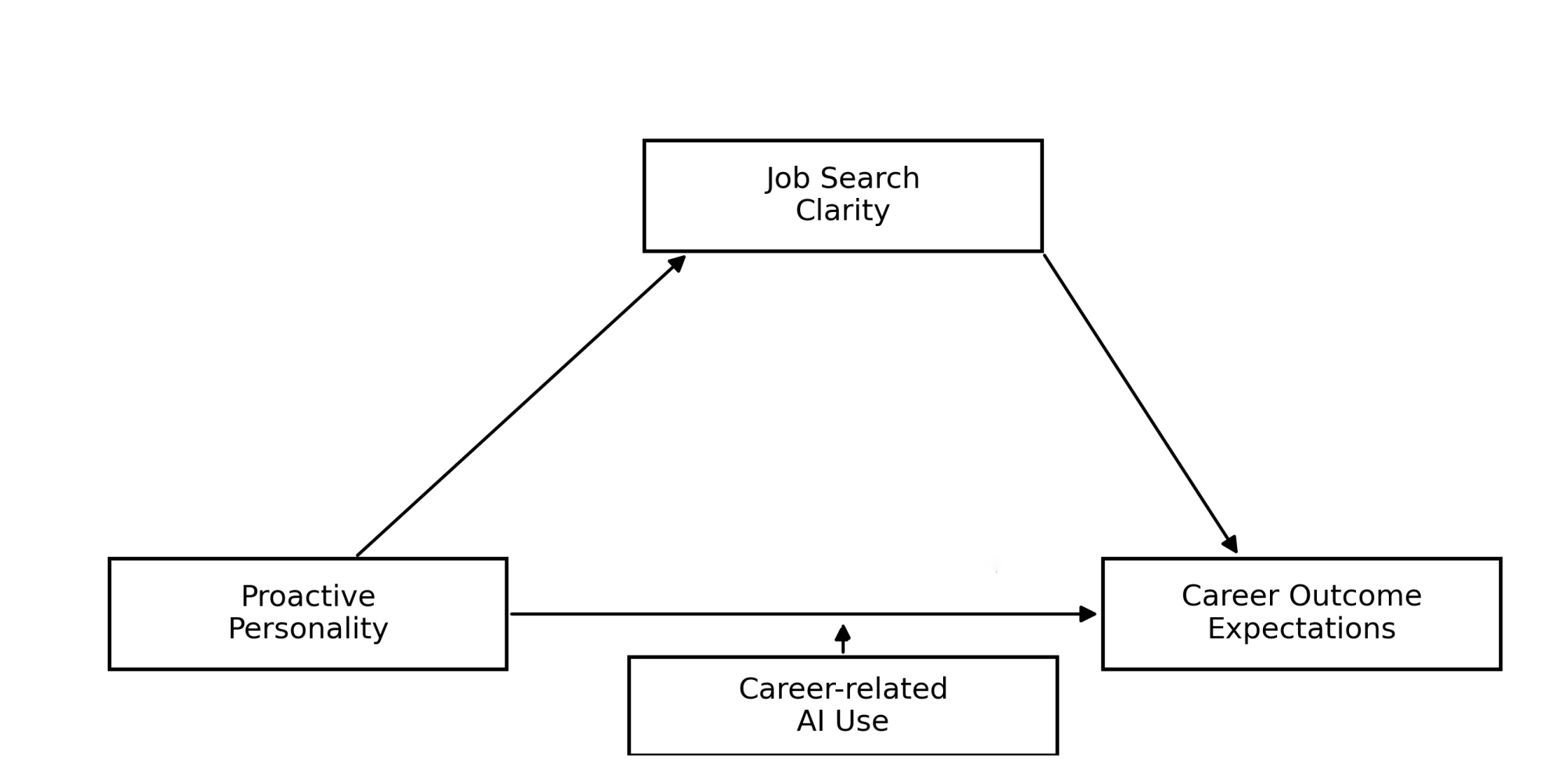
Note. Job search clarity is specified as a mediator. Career-related AI-use status is specified as a moderator of the direct association between proactive personality and career outcome expectations; the indirect pathway is not hypothesised to vary across groups.

Method

Participants
Data were collected in December 2023 through Wenjuanxing, an online questionnaire platform widely used in China. The survey yielded 800 submissions. Before analysis, responses were screened for data quality; 150 cases showing implausibly short completion times or evident patterned/inattentive responding were excluded. The final analytic sample comprised 650 valid questionnaires, corresponding to a retention rate of 81.3 per cent. Participants were recruited from a key undergraduate teacher education university in Hangzhou, China. Among the retained responses, 16.5 per cent were from male participants and 83.5 per cent from female participants, broadly reflecting the gender composition of teacher education programmes. The sample included 171 first-year, 151 second-year, 209 third-year and 119 fourth-year students. One student with extended study status was classified in the fourth-year group.

Measures
The questionnaire contained demographic items and measures of proactive personality, job search clarity, career outcome expectations and career-related AI use. The English-language scales were translated into Chinese and adapted to the context of pre-service teachers' career development. Before the formal survey, a small group of students from the same university reviewed the questionnaire, and ambiguous expressions were revised accordingly.
Proactive personality was measured with the six-item abbreviated Proactive Personality Scale examined by Claes et al. (2005), which was derived from the original scale developed by Bateman and Crant (1993). Items were rated on a five-point Likert scale ranging from 1 (completely disagree) to 5 (completely agree). The scale showed high internal consistency in the present sample (Cronbach's alpha = .93).
Job search clarity was measured with five items adapted from Cote et al. (2006). A sample item is: “I have clear goals for the career I want to pursue after graduation.” Items were rated on a five-point Likert scale from 1 (completely disagree) to 5 (completely agree). The scale showed high internal consistency in the present sample (Cronbach's alpha = .92).
Career outcome expectations were measured with 12 items adapted from the scale developed by Metheny (2009). A sample item is: “My career planning will lead to a satisfying career for me.” Items were rated on a five-point Likert scale from 1 (completely disagree) to 5 (completely agree). The scale showed high internal consistency in the present sample (Cronbach's alpha = .94).
Career-related AI use was measured with one binary item: “Have you ever used artificial intelligence tools to assist with career choice or employment decision-making?” Responses were coded 1 = yes and 2 = no. This variable indicates whether participants reported any such use; it does not measure use frequency, duration, task type, quality, perceived usefulness, trust, critical evaluation or AI literacy.

Ethical considerations
Participation was anonymous and voluntary. Before completing the questionnaire, participants were informed of the research purpose, the voluntary nature of participation and the research-only use of their responses. No personally identifying information was included in the analytic dataset. Participants could discontinue the questionnaire without penalty.

Data analysis
Data analysis proceeded in four stages. IBM SPSS Statistics 27.0 was used for preliminary analyses, including internal consistency, descriptive statistics and Pearson correlations. Composite scale scores were used only for these preliminary analyses; all hypothesis tests were conducted with item-level latent variable models.
Latent analyses were performed in Mplus 8.3 using the robust maximum-likelihood estimator. Proactive personality, job search clarity and career outcome expectations were modelled as latent constructs indicated by their original questionnaire items. The measurement structure was evaluated through single-construct confirmatory factor analyses (CFAs) and a full three-factor CFA. The hypothesised three-factor model was then compared with three theoretically plausible two-factor alternatives and a one-factor model. These comparisons were used to assess construct distinctiveness; the one-factor model was not treated as a definitive test of common method bias.
After the measurement model had been evaluated, a latent mediation model estimated the direct and indirect associations among proactive personality, job search clarity and career outcome expectations. Indirect effects, total effects, proportions mediated and between-group contrasts were specified with MODEL CONSTRAINT, and 95 per cent confidence intervals were reported for derived parameters. Career-related AI use was treated as a binary grouping variable. Configural, metric and scalar measurement invariance were examined before structural coefficients were compared. The multi-group model constrained the PP → JSC and JSC → COE paths to equality and freely estimated the direct PP → COE path across groups, thereby testing H3 as a difference in the direct association. This specification does not test whether the indirect association differs across AI-use groups.

Results

Measurement model analysis
Single-construct CFAs were first conducted for the three focal scales. As shown in Table 1, all factor loadings were significant, and the CFI, TLI and SRMR values generally supported the intended single-factor structures. RMSEA was elevated for job search clarity and proactive personality. Because both models had very low degrees of freedom, RMSEA was interpreted cautiously and considered together with the other fit indices rather than used as the sole criterion of adequacy.
The full three-factor measurement model, in which proactive personality, job search clarity and career outcome expectations were specified as separate latent constructs, showed acceptable fit. It also fitted the data substantially better than the three two-factor alternatives and the one-factor model (Table 1), supporting the empirical distinctiveness of the three focal constructs. The inferior fit of the one-factor model should not be interpreted as ruling out all common method variance.
Table 1. Measurement model fit and model comparison
Model | χ² | df | χ²/df | CFI | TLI | RMSEA [90% CI] | SRMR
Single-factor: JSC | 34.770 | 5 | 6.954 | .973 | .946 | .096 [.067, .127] | .021
Single-factor: COE | 232.407 | 54 | 4.304 | .928 | .912 | .071 [.062, .081] | .040
Single-factor: PP | 63.715 | 9 | 7.079 | .958 | .930 | .097 [.075, .120] | .029
Three-factor model | 646.129 | 227 | 2.846 | .935 | .928 | .053 [.048, .058] | .042
Two-factor: PP + JSC | 1685.250 | 229 | 7.359 | .775 | .752 | .099 | .095
Two-factor: PP + COE | 1532.867 | 229 | 6.694 | .799 | .778 | .094 | .076
Two-factor: JSC + COE | 1525.156 | 229 | 6.660 | .800 | .779 | .093 | .080
One-factor model | 2364.829 | 230 | 10.282 | .670 | .637 | .119 | .101
Note. PP = proactive personality; JSC = job search clarity; COE = career outcome expectations. All chi-square tests p < .001. CFI = comparative fit index; TLI = Tucker-Lewis index; RMSEA = root mean square error of approximation; SRMR = standardized root mean square residual.

Descriptive statistics and correlations
Of the 650 participants, 373 reported using AI tools for career-related decision-making and 277 reported no such use. Table 2 presents the means, standard deviations and bivariate correlations for the three focal variables. Proactive personality was positively correlated with both job search clarity and career outcome expectations, and job search clarity was positively correlated with career outcome expectations. These zero-order associations were consistent with the proposed model, although they do not establish temporal or causal ordering.
Table 2. Means, standard deviations and correlations
Variable | M | SD | 1 | 2 | 3
1. Proactive personality | 3.663 | .650 | —
2. Job search clarity | 3.689 | .740 | .476** | —
3. Career outcome expectations | 2.930 | .447 | .639** | .563** | —
Note. N = 650. **p < .01. Correlations are based on scale scores.

Measurement invariance across AI-use groups
Because the direct association was compared across AI-use groups, measurement invariance was assessed before structural coefficients were examined. The configural model showed acceptable fit, indicating that the same three-factor structure was tenable in both groups. The metric model, which constrained factor loadings to equality, also fitted acceptably. Changes from the configural to the metric model were negligible, supporting comparison of structural path coefficients. Scalar invariance was examined as a supplementary check; although latent mean comparisons were not a focus, the changes in fit remained within conventional cut-off criteria.
Table 3. Measurement invariance across AI-use groups
Model | χ² | df | χ²/df | CFI | TLI | RMSEA | SRMR | ΔCFI | ΔRMSEA | ΔSRMR
Configural | 889.332 | 454 | 1.959 | .935 | .928 | .054 | .046 | — | — | —
Metric | 911.534 | 474 | 1.923 | .935 | .931 | .053 | .054 | .000 | -.001 | .008
Scalar | 943.422 | 494 | 1.910 | .933 | .932 | .053 | .054 | -.002 | .000 | .000
Note. AI use was coded as 1 = use and 2 = non-use. All chi-square tests p < .001. Metric invariance was supported by negligible changes in CFI, RMSEA and SRMR; scalar invariance was reported as a supplementary check.

Latent mediation model
The mediation analysis retained the accepted three-factor latent measurement structure. Because the structural portion included a saturated set of regressions among the three latent constructs, its global fit was represented by the three-factor measurement model reported in Table 1 rather than by a separate more restrictive structural model.
As shown in Table 4, proactive personality was positively associated with job search clarity (B = .556, SE = .050, β = .506, 95% CI [.460, .656], p < .001). Job search clarity was positively associated with career outcome expectations when proactive personality was included (B = .199, SE = .032, β = .341, 95% CI [.140, .264], p < .001). The direct association between proactive personality and career outcome expectations also remained significant after job search clarity was included (B = .323, SE = .033, β = .503, 95% CI [.259, .391], p < .001), supporting H1.
The estimated indirect association between proactive personality and career outcome expectations through job search clarity was significant (B = .110, SE = .020, 95% CI [.075, .155], p < .001). The total association was also significant (B = .433, SE = .033, 95% CI [.369, .497], p < .001), and the indirect component accounted for 25.5 per cent of the total. In statistical terms, these results are consistent with partial mediation and support H2. Given the cross-sectional design, however, the indirect effect is interpreted as an associational decomposition rather than evidence of a causal temporal process.
Table 4. Latent mediation results
Effect / outcome | B / estimate | SE | β | 95% CI | p
PP → JSC | .556 | .050 | .506 | [.460, .656] | < .001
JSC → COE | .199 | .032 | .341 | [.140, .264] | < .001
PP → COE direct effect | .323 | .033 | .503 | [.259, .391] | < .001
Indirect effect: PP → JSC → COE | .110 | .020 | — | [.075, .155] | < .001
Total effect: PP → COE | .433 | .033 | — | [.369, .497] | < .001
Proportion mediated | .255 | .045 | — | [.174, .351] | < .001
R² for JSC | .256 | .044 | — | — | < .001
R² for COE | .542 | .035 | — | — | < .001
Note. PP = proactive personality; JSC = job search clarity; COE = career outcome expectations. B refers to the unstandardized coefficient, and β refers to the STDYX standardized coefficient. The proportion mediated was calculated as .110/.433 = 25.5%.

Multi-group comparison of the direct association
A multi-group latent SEM examined whether the direct association between proactive personality and career outcome expectations differed by self-reported career-related AI-use status. In accordance with the specified model, the PP → JSC and JSC → COE paths were constrained to equality across groups, whereas the direct PP → COE path was freely estimated. Proactive personality was positively associated with career outcome expectations in both the AI-use group (B = .267, SE = .039, 95% CI [.196, .346], p < .001) and the non-AI-use group (B = .368, SE = .039, 95% CI [.293, .444], p < .001).
The model-constraint test indicated that the direct coefficients differed significantly. Calculated as non-AI-use minus AI-use, the difference was positive (B = .101, SE = .045, 95% CI [.014, .189], p = .023). Thus, H3 was supported: the direct association between proactive personality and career outcome expectations was weaker among participants who reported career-related AI use. This group difference describes the observed pattern and should not be interpreted as evidence that AI use caused the attenuation.
Under the equality constraints imposed in the model, the common indirect association through job search clarity remained significant (B = .116, SE = .021, 95% CI [.080, .162], p < .001). The estimated total association was B = .383 in the AI-use group and B = .484 in the non-AI-use group. Because the two constituent indirect paths were constrained equal, these results do not constitute a test of moderated mediation.

Table 5. Multi-group latent SEM and group contrasts
Group / effect | Outcome | Path or contrast | B | SE | 95% CI | p / R²
AI-use group | JSC | PP → JSC | .561 | .049 | [.468, .661] | < .001; R² = .236
AI-use group | COE | JSC → COE | .207 | .032 | [.148, .274] | < .001; R² = .514
AI-use group | COE | PP → COE | .267 | .039 | [.196, .346] | < .001
Non-AI-use group | JSC | PP → JSC | .561 | .049 | [.468, .661] | < .001; R² = .303
Non-AI-use group | COE | JSC → COE | .207 | .032 | [.148, .274] | < .001; R² = .585
Non-AI-use group | COE | PP → COE | .368 | .039 | [.293, .444] | < .001
Common indirect effect | COE | PP → JSC → COE | .116 | .021 | [.080, .162] | < .001
Direct-effect difference | COE | Non-AI-use − AI-use | .101 | .045 | [.014, .189] | .023
Total effect in AI-use group | COE | PP → COE | .383 | .038 | [.313, .461] | < .001
Total effect in non-AI-use group | COE | PP → COE | .484 | .039 | [.414, .569] | < .001
Note. Coefficients are unstandardized estimates from Mplus. The PP → JSC and JSC → COE paths were constrained equal across groups by model specification; the direct PP → COE path was freely estimated. The direct-effect difference was calculated as the non-AI-use group minus the AI-use group. The model therefore tests group variation in the direct association, not variation in the indirect association.
Figure 2. Latent mediation model and group-specific direct associations by career-related AI use
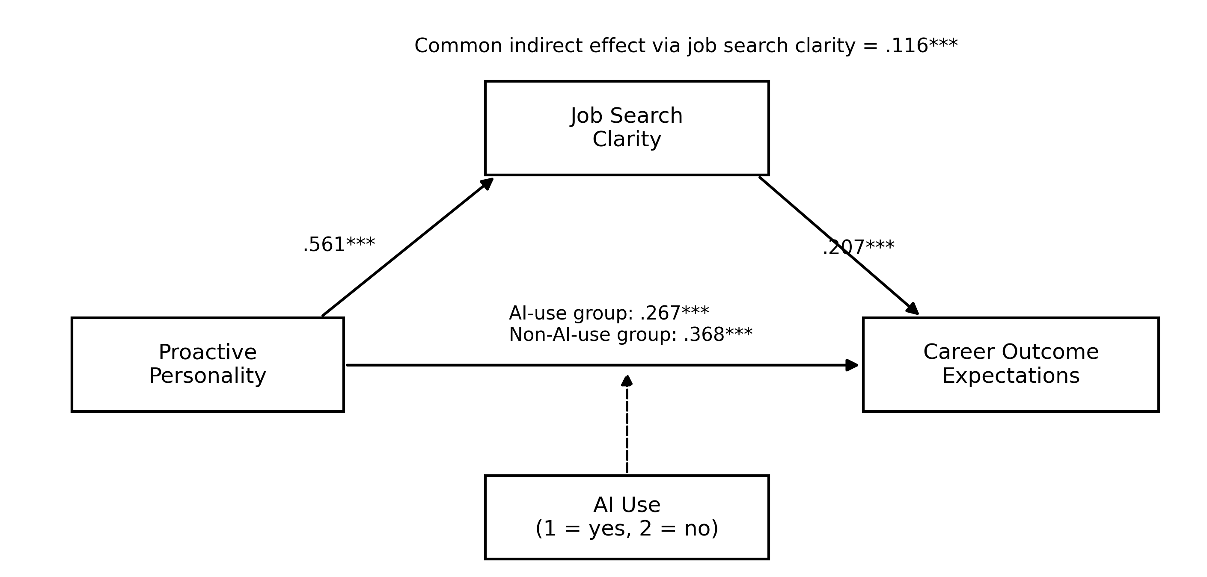
Note. Values are unstandardized coefficients from the multi-group latent structural equation model. The direct association between proactive personality and career outcome expectations differed across AI-use groups. The between-group difference was calculated as non-AI-use minus AI-use. *p < .05, ***p < .001.

Figure 3. Group-specific direct associations between proactive personality and career outcome expectations
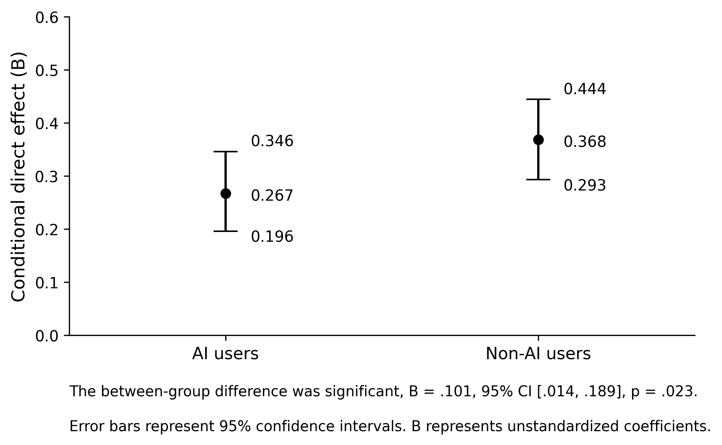
Note. Error bars represent 95% confidence intervals. The unstandardized direct coefficient was larger in the non-AI-use group than in the AI-use group.

Discussion and implications
This paper examined how proactive personality, job search clarity and self-reported career-related AI use were associated with career outcome expectations among pre-service teachers. Item-level latent-variable analyses indicated that proactive personality was positively associated with career outcome expectations directly and indirectly through job search clarity. The direct coefficient also differed across AI-use groups, being weaker among participants who reported career-related AI use. These findings support a model in which dispositional agency, goal clarity and digital career behaviour are related, while the cross-sectional design limits causal interpretation.
The indirect association through job search clarity is consistent with the social cognitive model of career self-management, which links personal agency, goal formation and career-related appraisals (Lent and Brown, 2013). Proactive pre-service teachers may be more inclined to scan the employment environment, seek information and convert broad concerns about the future into specific job-search goals. Clearer goals can then make potential pathways and their consequences easier to evaluate, strengthening beliefs that career-related effort will yield valued outcomes. This interpretation is consistent with evidence linking proactive personality to learning and development activities (Major et al., 2006) and linking career planning with adaptability and optimism (Rottinghaus et al., 2005).
The mediation was partial rather than complete. Job search clarity therefore represents one plausible cognitive link, not an exhaustive explanation of the association between proactive personality and career outcome expectations. Other mechanisms may include self-efficacy, access to professional networks, mastery experiences and perceived contextual support. For pre-service teachers, the result also highlights the distinction between possessing a proactive disposition and translating that disposition into a sufficiently specific understanding of preferred work. Teacher education programmes may therefore need to provide structured opportunities for students to compare career pathways, articulate job-search criteria and connect professional preparation with realistic employment requirements.
The group difference associated with career-related AI use is the most novel but also the most tentative finding. The direct PP → COE coefficient was weaker among AI users than among non-users. One possible explanation is that AI tools provide external informational structure, examples or prompts that make career exploration somewhat less dependent on individual proactivity. An alternative explanation is selection: students who are more uncertain, encounter different career barriers or possess different digital skills may be more likely to seek AI assistance. The present data cannot distinguish these mechanisms, and the observed group difference should not be treated as proof that AI use substitutes for personal agency.
The attenuation pattern also should not be interpreted as evidence that AI use is inherently beneficial or harmful. The grouping item captured whether participants had ever used AI to assist career choice or employment decision-making, but not what tools they used, how frequently they used them, what tasks they completed, whether they checked the information or how much they trusted it. Moreover, the AI-use and non-AI-use groups were not formed through random assignment. The result is therefore best understood as a conditional association linked to self-reported use status rather than as an estimated treatment effect of AI-supported career guidance.
The findings nevertheless have practical implications for teacher education. Career-development support should combine dispositional development with structured goal clarification rather than relying on general confidence-building or employability rhetoric. AI-supported activities may be useful when they are embedded in guided tasks such as comparing teaching and non-teaching pathways, refining job-search criteria, generating interview-preparation questions and checking claims against authoritative information. The central implication is not to encourage AI use indiscriminately, but to help pre-service teachers use AI as a critically evaluated resource within a broader career self-management process.

Conclusion, limitations and future research
The paper extends career self-management research by showing that proactive personality is associated with pre-service teachers' career outcome expectations both directly and indirectly through job search clarity. It also identifies self-reported career-related AI-use status as a boundary condition of the direct association: the coefficient was smaller among AI users than among non-users. This pattern qualifies simple technology-optimistic assumptions, but it does not establish that AI use caused the difference or that AI tools replaced individual agency. The contribution lies in identifying a theoretically interpretable group difference that warrants more direct longitudinal and experimental investigation.
Several limitations should be acknowledged. First, the cross-sectional design does not establish the temporal ordering or causal direction of the associations among proactive personality, job search clarity, AI use and career outcome expectations. Longitudinal and intervention studies are needed across the teacher-education-to-employment transition. Second, participants were drawn from one teacher education university in China, limiting generalisability across institutions, regions and labour-market contexts. Third, AI use was represented by one binary item. Future research should distinguish frequency, purpose, duration, quality, perceived usefulness, trust, critical evaluation and AI literacy. Fourth, the AI-use groups were self-selected and may differ on unmeasured characteristics, including grade level, career uncertainty and digital competence. Fifth, the multi-group model constrained the PP → JSC and JSC → COE paths to equality because the hypothesis concerned the direct path; future analyses should test these structural equality constraints explicitly and examine whether the indirect association is itself conditional. Finally, career outcome expectations are beliefs rather than actual career behaviour. Subsequent research should incorporate job-search intensity, application behaviour, teaching-entry intention and early employment outcomes.

Declaration of conflicting interests
The author(s) declared no potential conflicts of interest with respect to the research, authorship and/or publication of this article.

Funding
This research was funded by a general project of the National Social Science Fund of China, “Research on the Path and Measurement for Empowering Private Colleges for High-Quality Development through Educational Supervision in the Digital Age” (Grant number BIA230199).

References
Akiba, D. and Fraboni, M.C. (2023), "AI-supported academic advising: exploring AI's current state and future potential toward student empowerment", Education Sciences, Vol. 13 No. 9, 885.
Bateman, T.S. and Crant, J.M. (1993), "The proactive component of organizational behavior: a measure and correlates", Journal of Organizational Behavior, Vol. 14 No. 2, pp. 103-118.
Claes, R., Beheydt, C. and Lemmens, B. (2005), "Unidimensionality of abbreviated proactive personality scales across cultures", Applied Psychology, Vol. 54 No. 4, pp. 476-489.
Conklin, A.M., Dahling, J.J. and Garcia, P.A. (2013), "Linking affective commitment, career self-efficacy, and outcome expectations: a test of social cognitive career theory", Journal of Career Development, Vol. 40 No. 1, pp. 68-83.
Cote, S., Saks, A.M. and Zikic, J. (2006), "Trait affect and job search outcomes", Journal of Vocational Behavior, Vol. 68 No. 2, pp. 233-252.
Domene, J.F. (2012), "Calling and career outcome expectations: the mediating role of self-efficacy", Journal of Career Assessment, Vol. 20 No. 3, pp. 281-292.
Gedrimiene, E., Celik, I., Kaasila, A. and Muukkonen, H. (2024), "Artificial Intelligence (AI)-enhanced learning analytics (LA) for supporting career decisions: advantages and challenges from user perspective", Education and Information Technologies, Vol. 29, pp. 297-322.
Klassen, R.M. and Chiu, M.M. (2011), "The occupational commitment and intention to quit of practicing and pre-service teachers: influence of self-efficacy, job stress, and teaching context", Contemporary Educational Psychology, Vol. 36 No. 2, pp. 114-129.
Le, S.T. and Lin, S.P. (2023), "Proactive personality and the job search outcomes: the mediating role of networking behaviour", British Journal of Guidance & Counselling, Vol. 51 No. 1, pp. 29-45.
Lent, R.W. and Brown, S.D. (2013), "Social cognitive model of career self-management: toward a unifying view of adaptive career behavior across the life span", Journal of Counseling Psychology, Vol. 60 No. 4, pp. 557-568.
Lent, R.W., Brown, S.D. and Hackett, G. (1994), "Toward a unifying social cognitive theory of career and academic interest, choice, and performance", Journal of Vocational Behavior, Vol. 45 No. 1, pp. 79-122.
Lent, R.W., Ireland, G.W., Penn, L.T., Morris, T.R. and Sappington, R.T. (2017), "Sources of self-efficacy and outcome expectations for career exploration and decision-making: a test of the social cognitive model of career self-management", Journal of Vocational Behavior, Vol. 99, pp. 107-117.
Major, D.A., Turner, J.E. and Fletcher, T.D. (2006), "Linking proactive personality and the Big Five to motivation to learn and development activity", Journal of Applied Psychology, Vol. 91 No. 4, pp. 927-935.
Metheny, J.R. (2009), Family of Origin Influences on the Career Development of Young Adults: The Relative Contributions of Social Status and Family Support, Doctoral dissertation, University of Oregon, Eugene, OR.
Rottinghaus, P.J., Day, S.X. and Borgen, F.H. (2005), "The career futures inventory: a measure of career-related adaptability and optimism", Journal of Career Assessment, Vol. 13 No. 1, pp. 3-24.
Rots, I., Aelterman, A. and Devos, G. (2014), "Teacher education graduates' choice (not) to enter the teaching profession: does teacher education matter?", European Journal of Teacher Education, Vol. 37 No. 3, pp. 279-294.
UNESCO and International Task Force on Teachers for Education 2030 (2024), Global Report on Teachers: Addressing Teacher Shortages and Transforming the Profession, UNESCO, Paris.
van Katwijk, L., Berry, A., Jansen, E. and van Veen, K. (2019), "It's important, but I'm not going to keep doing it!": perceived purposes, learning outcomes, and value of pre-service teacher research among educators and pre-service teachers", Teaching and Teacher Education, Vol. 86, 102868.
Wanberg, C.R., Hough, L.M. and Song, Z. (2002), "Predictive validity of a multidisciplinary model of reemployment success", Journal of Applied Psychology, Vol. 87 No. 6, pp. 1100-1120.
Xin, L., Zhou, W., Li, M. and Tang, F. (2020), "Career success criteria clarity as a predictor of employment outcomes", Frontiers in Psychology, Vol. 11, 540.
Ye, W., Wang, Z., Zhang, X., Ding, Y. and Ye, W. (2021), "Comparing motivations of pre-service and beginning teachers in China: impact of culture and experience", Journal of Education for Teaching, Vol. 47 No. 4, pp. 576-589.

Corresponding author
Jingyi Lou can be contacted at: 51284102015@stu.ecnu.edu.cn

